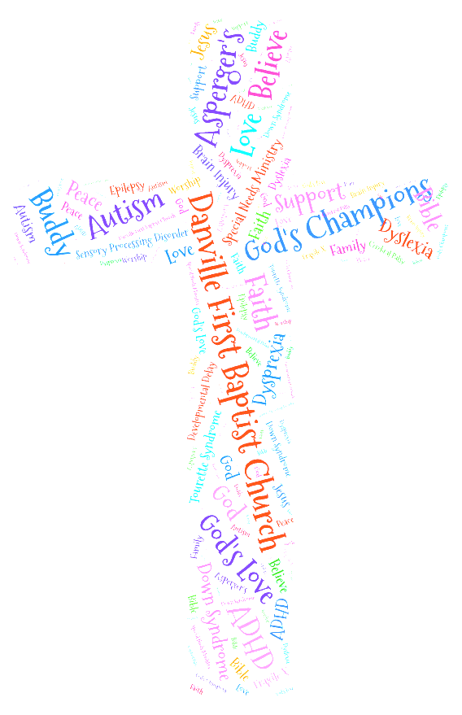

"We are community in Christ, reaching our community for Christ"

**God's Champions Family Survey**

*Please give as much information so we can make the experience the best for your child*

*and your family. All information is confidential and is only given to those with a need to know.*

|  |  |  |  |  |  |  |  |  |  |  |  |  |  |  |  |  |  |  |  |
| --- | --- | --- | --- | --- | --- | --- | --- | --- | --- | --- | --- | --- | --- | --- | --- | --- | --- | --- | --- |
| Date: |  | | | | | | | | | | | | | | | | | | |
| Child’s Name: | | |  | | | | | | Date of Birth: | | | | |  | | | | | |
| Mother: |  | | | | | | Father: | | | |  | | | | | | | | |
| Child lives with : | | | | | 󠆸 Both Parents | | 󠆸 Mother | | | | | | | 󠆸 Father | | | | | |
| Guardian (Please note relationship if applicable): | | | | | |  | | | | | | | | | | | | | |
| Street: |  | | | | | | | | | | | | | | | | | | |
| City: |  | | | | | | | | | State: | |  | | | | Zip: | | |  |
| Phone (Home): | |  | | | | | | Phone (Cell) | | | | |  | | | | | | |
|  | | | | | | | | | | | | | | | | | | | |
| Please list any siblings who will also be attending: | | | | | | | | | | | | | | | | | | | |
| Name: |  | | | | | | | | | | | | | | Age: | | |  | |
| Name: |  | | | | | | | | | | | | | | Age: | | |  | |
| Name: |  | | | | | | | | | | | | | | Age: | | |  | |
| Name: |  | | | | | | | | | | | | | | Age: | | |  | |
|  | | | | | | | | | | | | | | | | | | | |
| EMERGENCY CONTACTS: In case of Emergency, the following person(s) may be called and are authorized to pick up my child. At least one contact must be provided. | | | | | | | | | | | | | | | | | | | |
| **Name:** |  | | | | | | | | | | | Relationship: | | | | |  | | |
| Street: |  | | | | | | | | | | | | | | | | | | |
| City: |  | | | | | | | | | State: | |  | | | | Zip: | | |  |
| Phone (Home): | | | |  | | | | Phone (Cell) | | | | |  | | | | | | |

|  |  |  |  |  |  |  |  |  |  |
| --- | --- | --- | --- | --- | --- | --- | --- | --- | --- |
| **Name:** |  | | | | Relationship: | | |  | |
| Street: |  | | | | | | | | |
| City: |  | | | State: |  | | Zip: | |  |
| Phone (Home): | |  | Phone (Cell) | | |  | | | |
|  | | | | | | | | | |
| ***Family Information:*** | | | | | | | | | |
| What parts of church life do you and your family desire to participate in? | | | | | | | | | |
|  | | | | | | | | | |
|  | | | | | | | | | |
| What prevents your family from participating in and serving in church programs? | | | | | | | | | |
|  | | | | | | | | | |
|  | | | | | | | | | |
| What support is necessary for you and your family to fully participate in the body of Christ? | | | | | | | | | |
|  | | | | | | | | | |
|  | | | | | | | | | |
| What are your immediate needs, inside and/or outside the church? | | | | | | | | | |
|  | | | | | | | | | |
|  | | | | | | | | | |
| What is your dream for your child spiritually? | | | | | | | | | |
|  | | | | | | | | | |
|  | | | | | | | | | |
| ***Sibling Information:*** | | | | | | | | | |
| The sibling of the child with disability is affected in the following ways- | | | | | | | | | |
|  | | | | | | | | | |
|  | | | | | | | | | |
| What can we as a church do to support this child? | | | | | | | | | |
|  | | | | | | | | | |
|  | | | | | | | | | |

|  |
| --- |
| ***Behavior Information:*** |
| My Child responds to separation from his/her parents/guardians by: |
|  |
|  |
| My child is best comforted/calmed by: |
|  |
|  |
| My child lets someone know what he/she wants by: |
|  |
|  |
| What type of play activities does your child enjoy and/or participate in? |
|  |
|  |
| My child becomes upset when: |
|  |
|  |
| My child does not enjoy: |
|  |
|  |
| My child does/does not enjoy music. Please explain: |
|  |
|  |
| My child seems most relaxed in settings alone/ with a few children/among many children. Please explain: |
|  |
|  |
| My child is really picky about: |
|  |
|  |

|  |  |  |  |  |  |  |  |  |  |  |  |  |  |  |  |  |
| --- | --- | --- | --- | --- | --- | --- | --- | --- | --- | --- | --- | --- | --- | --- | --- | --- |
| Does your child sensory seek/become overstimulated/ both? Please explain: | | | | | | | | | | | | | | | | |
|  | | | | | | | | | | | | | | | | |
|  | | | | | | | | | | | | | | | | |
| Are there any additional behavioral concerns not already addressed? | | | | | | | | | | | | | | | | |
|  | | | | | | | | | | | | | | | | |
|  | | | | | | | | | | | | | | | | |
| What do you need us to know or understand about your child? | | | | | | | | | | | | | | | | |
|  | | | | | | | | | | | | | | | | |
|  | | | | | | | | | | | | | | | | |
|  | | | | | | | | | | | | | | | | |
| **Care Needs:** (Please check all that apply) | | | | | | | | | | | | | | | | |
| Hearing | 󠆸 Typical | | | | 󠆸 Impaired | | | | 󠆸 Hearing Aid | | | | | 󠆸 Deaf | | |
| Motor | 󠆸 Head Control | | | | 󠆸 Rolls Over | | | 󠆸 Sits (unassisted) | | | | 󠆸 Crawls | | | | 󠆸 Walks |
| Uses | 󠆸 Walker | | | | 󠆸 Crutches | | | | 󠆸 Braces | | | | | 󠆸 Wheelchair | | |
| Additional Information or explanation: | | | | | | | | | | | | | | | | |
|  | | | | | | | | | | | | | | | | |
|  | | | | | | | | | | | | | | | | |
| **Communication:** (Please check all that apply) | | | | | | | | | | | | | | | | |
| 󠆸 Words | | 󠆸 Phrases | | 󠆸 Sentences | | | 󠆸 Babbles | | | | 󠆸 Gestures | | | | 󠆸 Sign Language | |
| My child can understand what other say: | | | 󠆸 All of the time | | | 󠆸 Most of the time | | | | 󠆸 Some of the time | | | 󠆸 Recognizes voices of family members | | | |
| Languages spoken at home: | | | | | | | | | | | | | | | | |
| Languages spoken at home: | | | | | | | | | | | | | | | | |
|  | | | | | | | | | | | | | | | | |
|  | | | | | | | | | | | | | | | | |
| Additional Information or explanation: | | | | | | | | | | | | | | | | |
|  | | | | | | | | | | | | | | | | |
|  | | | | | | | | | | | | | | | | |

|  |  |  |  |  |  |  |  |
| --- | --- | --- | --- | --- | --- | --- | --- |
| **Eating Habits:**(please check all that apply) | | | | | | | |
| 󠆸 Self feeds | 󠆸 Uses fork | | 󠆸 Uses spoon | 󠆸 Uses hands | | 󠆸 Requires eating assistance | |
| 󠆸 Self drink | 󠆸 Uses cup | | 󠆸 Uses bottle | 󠆸 Requires drinking assistance | | | |
|  | | | | | | | |
| Additional Information or explanation: | | | | | | | |
|  | | | | | | | |
|  | | | | | | | |
| **Allergies:** | | | | | | | |
|  | | | | | | | |
|  | | | | | | | |
| **Toileting Skills:** (please check all that apply) | | | | | | | |
| 󠆸 Toilets independent | | 󠆸 Potty trained, needs assistance | | | 󠆸 Scheduled | | 󠆸 Diapers |
| How does your child indicate a need to use the toilet? | | | | | | | |
|  | | | | | | | |
| Additional Information or explanation: | | | | | | | |
|  | | | | | | | |
|  | | | | | | | |
| Anything additional that you would like us to know: | | | | | | | |
|  | | | | | | | |
|  | | | | | | | |

**Permission and Authorization Agreement:**

**Please read the following statements carefully and initial in the designated space indicating you have read, understand and agree to the provisions.**

I have fully disclosed to Danville First Baptist Church all pertinent facts about my child's special needs and accept full responsibility for missing information.

I understand the nature of the program and do hereby release Danville First Baptist Church and its representatives from liability due to accident or injury of my child.

I have read and understood fully the goals of the program and understand what they do and do not provide as a program.

Signature: Date: